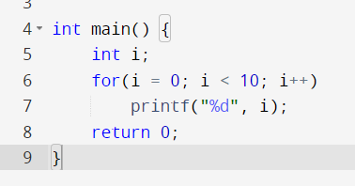

**How many iterations will this loop have?**

10

**What will this loop output?**

0123456789

**What is the value of i after the loop is finished?**

10

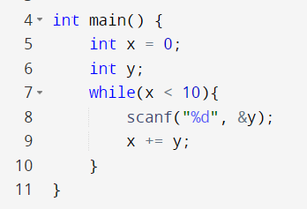

**When will this loop end?**

When the user enters numbers that sum up to a value 10 or greater

**Should this have been written as a for loop?**

No

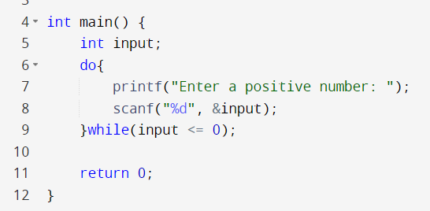

**Why do we use a do-while loop for this code?**

- We want to iterate at least once

- We need to get the input before we check if it's valid

**Could this have been written as a while loop?**

Yes, but input would need to be initialized before the loop

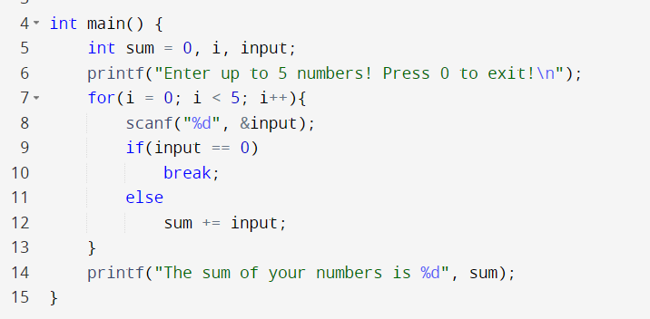

**What does line 10 in this code do?**

It ends the loop

**What is wrong with this code?**

It's a violation of the single entry single exit principle

**How can we fix it?**

Add a flag

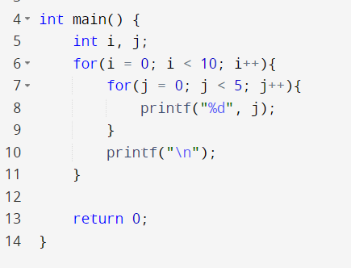

**How many iterations of the child loop will be executed in this code?**

50 **How can you calculate the number of iterations a nested for loop will have?**

You multiply the number of iterations of the parent loop by the number of iterations of the child loop